Tracy Michaels
Lab 2

Question A) /home/tmichaels1

Question B) ls now shows the directory ‘csc3320’ where as before it didn’t print anything to the terminal

Question C) pwd shows /home/tmichaels1/csc3320

Question D) mkdir lab2

Question E) cd lab2

Question F) the > character is an output redirection, it takes the output from cat and puts it into myLab2.txt. Ctrl-D ends input for cat
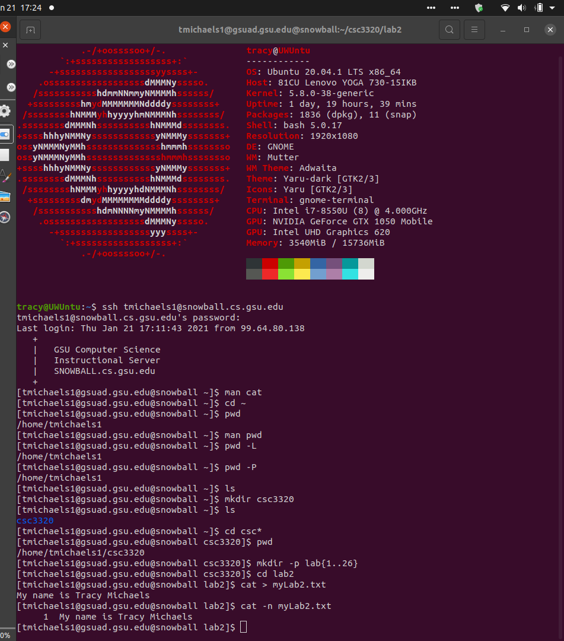
Question G)

Question H)
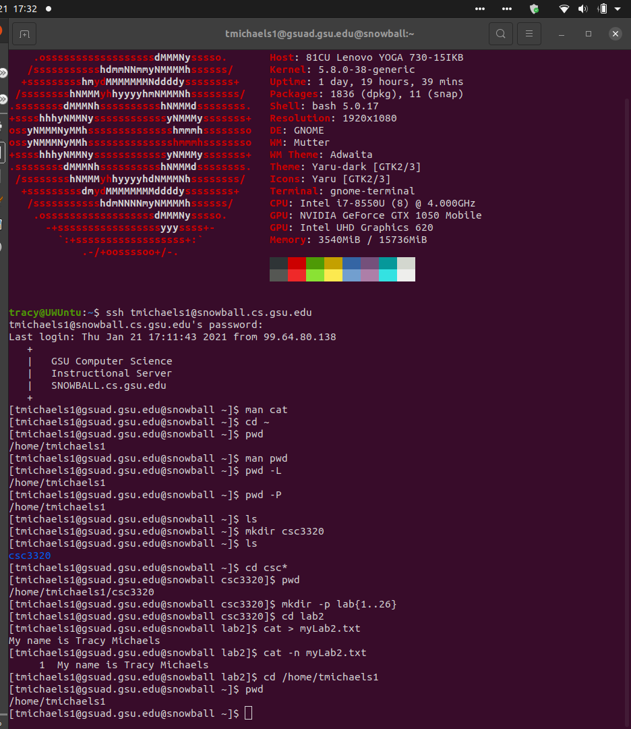
QQuestion H)

